
Company
Logotype

Cone Beam Computed Tomography- Report



Porur Dental X-rays & CBCT

Patient Name : Mr. Prakash Thooyamani | Date of Report : 17.03.2024
Age/ Gender : 40 years/ Male | Region of Interest : CBCT Mandible
Referring doctor: 32 Dental Care | Indication : I.A.Nerve proximity in right side
Clinical Notes: Nil
PATIENT INFORMATION

CBCT- Mandible provided
CBCT – IMAGE DETAILS

RADIOGRAPHIC INTERPRETATION

- No of teeth present in the right side of mandibular arch : 8
- The long axis of 48 appears to be perpendicular to the long axis of the adjacent 47 tooth.
- The crown of 48 is present partially within the ascending ramus of mandible and appears to impinge onto the disto-coronal aspect of 47.
- The disto-coronal aspect of 47 is present with diffuse hypodense area involving the enamel, dentin and approximating the pulp.
- Distance between the root of 48 and the Inferior Alveolar Nerve canal: in contact
- Distance between the crown of 48 and the Inferior Alveolar Nerve canal: 5.25 mm

RADIOGRAPHIC IMPRESSION

- Horizontally impacted tooth: 48.
- Dental caries involving pulp: 47.

Kindly correlate with clinical findings


IMAGES FOR REFERENCE

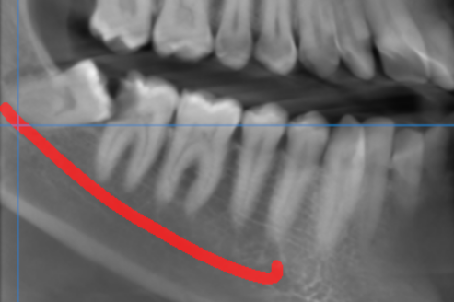

3-DIMENSIONAL VIEW

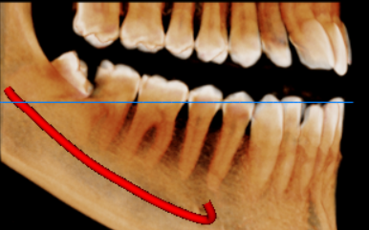

CROSS SECTIONAL VIEW

48 region- root in contact with the inferior alveolar nerve canal | 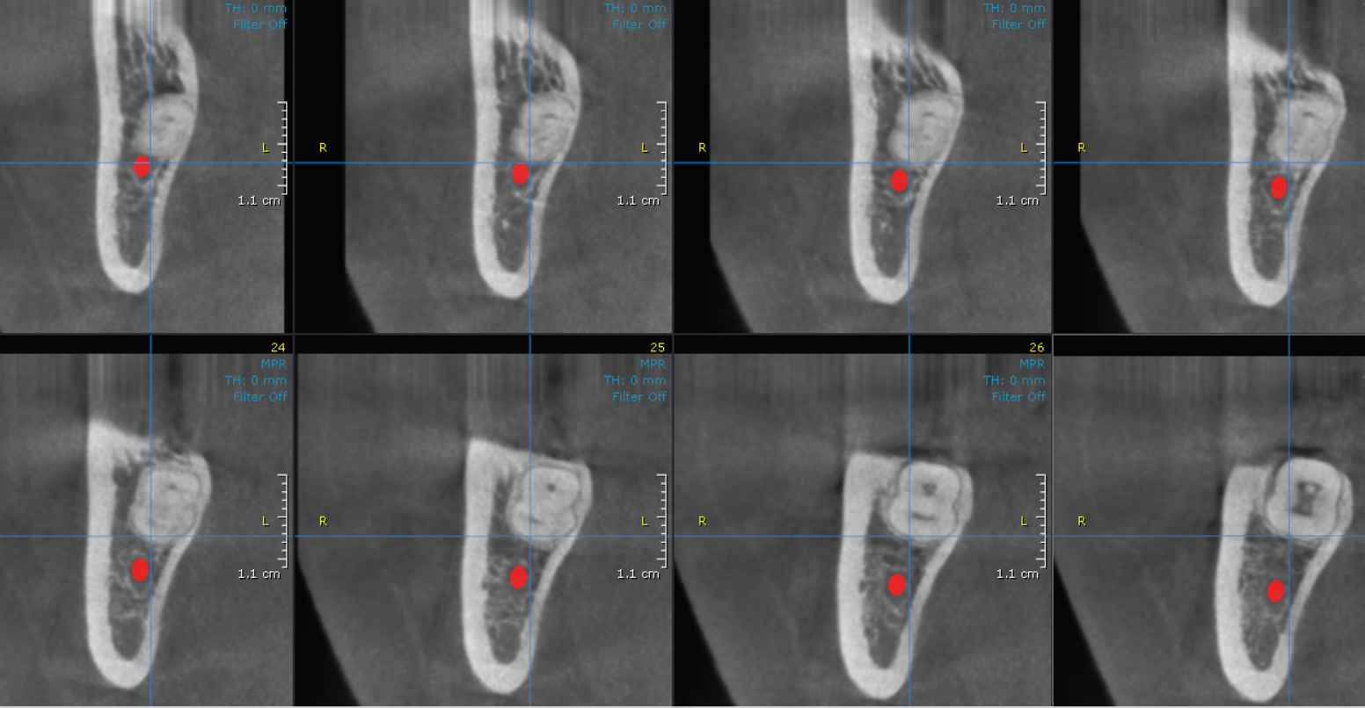

**** End of report ****

